**NALLA MALLA REDDY ENGINEERING COLLEGE**

**Autonomous Institution**

Accredited by **NAAC** with **‘A’** Grade, **NBA** Accredited B.Tech Programs, Approved by AICTE

DIVYANAGAR, GhatkesarMandal, Medchal - Malkajgiri District, Telangana, India  - 500088

DEPARTMENT OF COMPUTER SCIENCE AND ENGINEERING

A

COURSE LEVEL PROJECT

ON

**TOURISM WEBSITE**

**SUB:FULL STACK WEB DEVELOPMENT**

PRESENTED BY:

**G.SAI PRASAD(20B61A0549)**

**A.SRI RAMA KRISHNA(20B61A0512)**

**B.ABHISHEK(20B61A0518)**

**A.ABHISHEK(21B65A0501)**

**A.SAI THEJA(21B65A0502)**

**B.PRASHANTH(21B65A0503)**

**J.ABHINAY(21B65A0512)**

**K.SHARATH BABU(21B65A0513)**

COORDINATOR HEAD OF THE DEPARTMENT

Aim:TO CREATE A WEBSITE USING HTML AND CSS.

THEORY:

The tourism and travel industry has become more accessible than ever. The internet has made it easier to research, plan and book trips, all with just a few clicks. You can find everything from flights, hotels, and restaurants to car rentals and local experiences online.

A tourism or travel website serves as an information hub for prospective travelers planning a getaway. Today, people travel for a range of experiences—babymoons, staycations, voluntourism or bleisure—you name it. So, provide as much relevant information as possible to help users plan their trips.

**Header Section of  travel website**

First, in the header section of our website, we will add a navbar for our travel website using the <nav> tag, and inside the nav tag, we will create different navbar links for our website navbar using an unordered list.

Inside our header section, we will add another section called “banner,” within which we will add a heading using the <h1> tag; a text input box using the form tag; a menu list for selecting the countries from the menu list; an input of type “date” to select the date from the calendar; and a book button using the <a> tag.

#### Body Section of travel website

In the body section, we will develop three sections: one for services, one for places, and one for about us. In this section, we will introduce several structures. Within our services section, we will use the <div> to create a container for our service items, and within our div tag, we will add an image and a sub-heading using the <h2>, as well as three more service items.

Concerning the places portion, we will create the locations in card format. In our places sections, we will first create some div tags, and within those, we will add an image related to the place using the img> tag, and the text for that place using another div tag. We’ll use the span and h2 tags inside that div to add a rating for the place, and the h2 tag to add the subheading of our place items. We’ll make 5 more image cards with zoom features like this one.

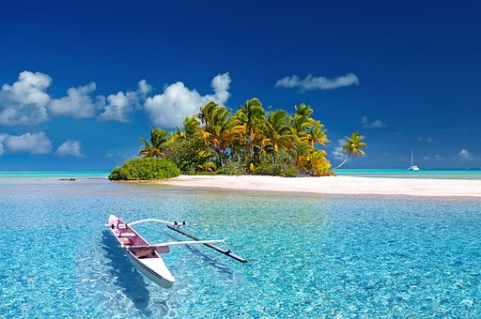

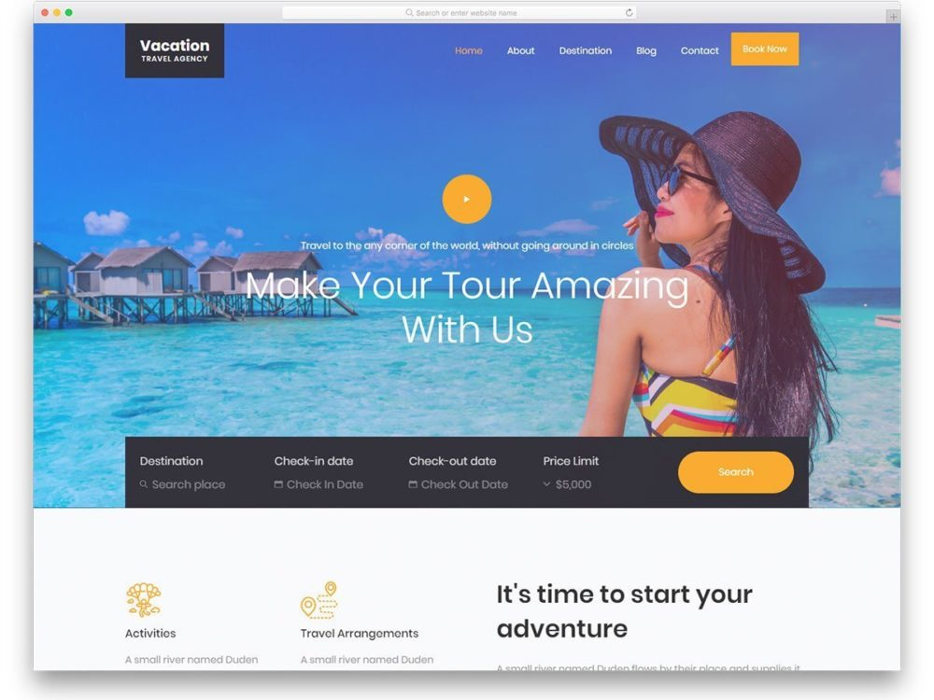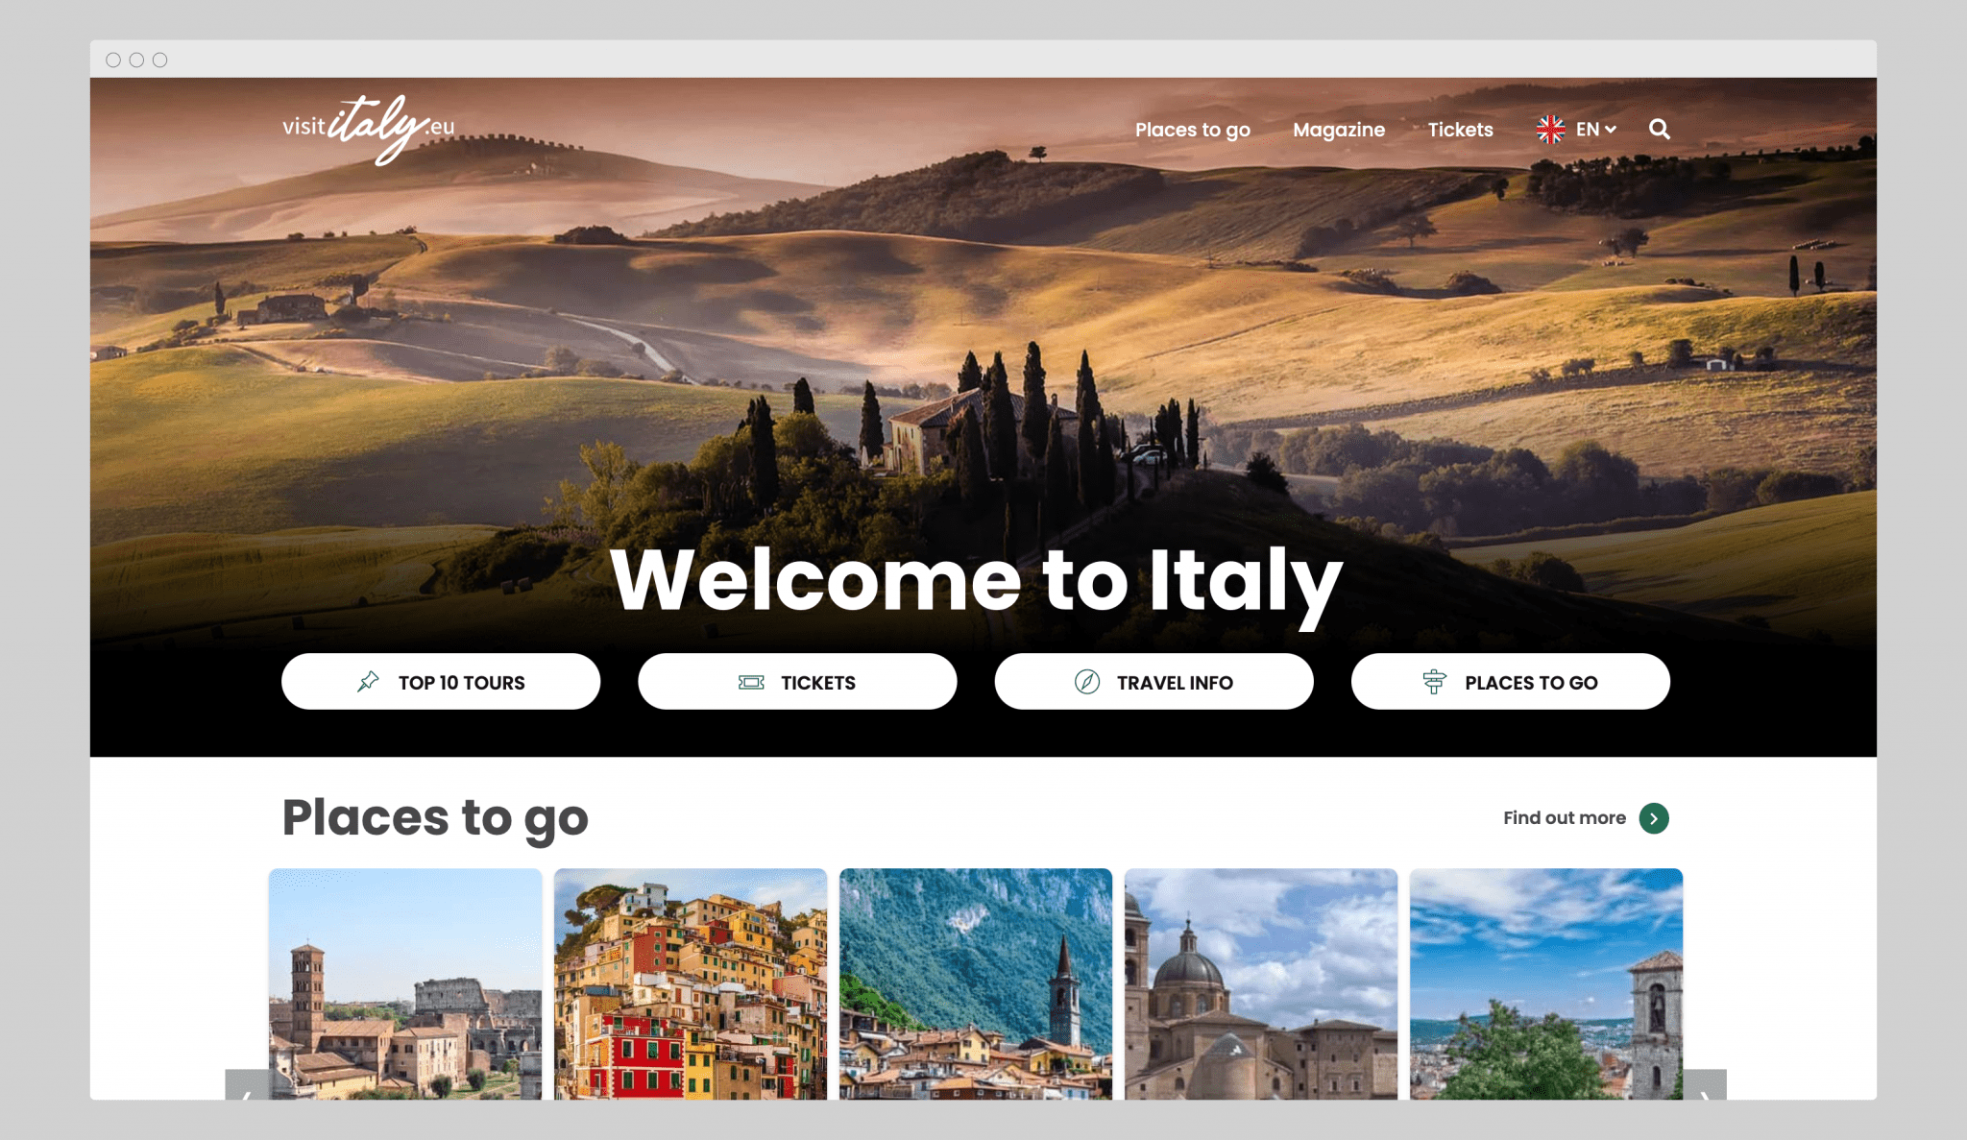

HTML SOURCE CODE:

<!DOCTYPE html>

<html>

<head>

<link rel="stylesheet" href="https://stackpath.bootstrapcdn.com/bootstrap/4.5.2/css/bootstrap.min.css" integrity="sha384-JcKb8q3iqJ61gNV9KGb8thSsNjpSL0n8PARn9HuZOnIxN0hoP+VmmDGMN5t9UJ0Z" crossorigin="anonymous">

<script src="https://code.jquery.com/jquery-3.5.1.slim.min.js" integrity="sha384-DfXdz2htPH0lsSSs5nCTpuj/zy4C+OGpamoFVy38MVBnE+IbbVYUew+OrCXaRkfj" crossorigin="anonymous"></script>

<script src="https://cdn.jsdelivr.net/npm/popper.js@1.16.1/dist/umd/popper.min.js" integrity="sha384-9/reFTGAW83EW2RDu2S0VKaIzap3H66lZH81PoYlFhbGU+6BZp6G7niu735Sk7lN" crossorigin="anonymous"></script>

<script src="https://stackpath.bootstrapcdn.com/bootstrap/4.5.2/js/bootstrap.min.js" integrity="sha384-B4gt1jrGC7Jh4AgTPSdUtOBvfO8shuf57BaghqFfPlYxofvL8/KUEfYiJOMMV+rV" crossorigin="anonymous"></script>

</head>

<body>

<div id="sectionHome">

<div class="bg-container d-flex flex-column justify-content-end">

<div class="tourism-card">

<h1 class="main-heading">Tourism</h1>

<p class="paragraph">Plan your trip.</p>

<button class="button" onclick="display('sectionFavouritePlaces')">

Get Started

</button>

</div>

</div>

</div>

<div id="sectionFavouritePlaces">

<div class="favourite-places-bg-container">

<h1 class="favourite-places-heading">Favourite Places</h1>

<div class="favourite-place-card-container d-flex flex-row" onclick="display('sectionTajMahalDetailedView')">

<div>

<h1 class="favourite-place-card-heading">Taj Mahal</h1>

<p class="favourite-place-card-description">

If there was just one symbol to represent all of India, it would

be the Taj Mahal

</p>

</div>

<img src="https://d1tgh8fmlzexmh.cloudfront.net/ccbp-static-website/tajmahal-img.png" class="favourite-place-card-image" />

</div>

<div class="favourite-place-card-container d-flex flex-row" onclick="display('sectionGoldenTempleDetailedView')">

<div>

<h1 class="favourite-place-card-heading">Golden Temple</h1>

<p class="favourite-place-card-description">

Amritsar is world-famous for the beautiful and highly revered

Golden Temple

</p>

</div>

<img src="https://d1tgh8fmlzexmh.cloudfront.net/ccbp-static-website/golden-temple-img.png" class="favourite-place-card-image" />

</div>

<div class="favourite-place-card-container d-flex flex-row" onclick="display('sectionMysorePalaceDetailedView')">

<div>

<h1 class="favourite-place-card-heading">Mysore Palace</h1>

<p class="favourite-place-card-description">

The Mysore Palace is a historical palace and the royal residence

at Mysore.

</p>

</div>

<img src="https://d1tgh8fmlzexmh.cloudfront.net/ccbp-static-website/mysore-palace-img.png" class="favourite-place-card-image" />

</div>

<div class="favourite-place-card-container d-flex flex-row" onclick="display('sectionVaranasiTemple')">

<div>

<h1 class="favourite-place-card-heading">Varanasi Temple</h1>

<p class="favourite-place-card-description">

Varanasi Temple is most famous Hindu temples dedicated to Lord

Shiva

</p>

</div>

<img src="https://d1tgh8fmlzexmh.cloudfront.net/ccbp-static-website/varanasi-temple-img.png" class="favourite-place-card-image" />

</div>

<button class="btn btn-dark" onclick="display('sectionHome')">

back

</button>

</div>

</div>

<div id="sectionTajMahalDetailedView">

<div class="detailed-view-bg-container">

<h1 class="detailed-view-heading">Detailed View</h1>

<div class="detailed-view-card-container">

<div id="carouselExampleIndicators" class="carousel slide" data-ride="carousel">

<ol class="carousel-indicators">

<li data-target="#carouselExampleIndicators" data-slide-to="0" class="active"></li>

<li data-target="#carouselExampleIndicators" data-slide-to="1"></li>

<li data-target="#carouselExampleIndicators" data-slide-to="2"></li>

</ol>

<div class="carousel-inner">

<div class="carousel-item active">

<img src="https://d1tgh8fmlzexmh.cloudfront.net/ccbp-static-website/tajmahal-c1-img.png" class="d-block w-100" alt="..." />

</div>

<div class="carousel-item">

<img src="https://d1tgh8fmlzexmh.cloudfront.net/ccbp-static-website/tajmahal-c2-img.png" class="d-block w-100" alt="..." />

</div>

<div class="carousel-item">

<img src="https://d1tgh8fmlzexmh.cloudfront.net/ccbp-static-website/tajmahal-c3-img.png" class="d-block w-100" alt="..." />

</div>

</div>

<a class="carousel-control-prev" href="#carouselExampleIndicators" role="button" data-slide="prev">

<span class="carousel-control-prev-icon" aria-hidden="true">

</span>

<span class="sr-only">Previous</span>

</a>

<a class="carousel-control-next" href="#carouselExampleIndicators" role="button" data-slide="next">

<span class="carousel-control-next-icon" aria-hidden="true">

</span>

<span class="sr-only">Next</span>

</a>

</div>

<div class="detailed-view-card-text-container">

<h1 class="detailed-view-card-heading">Taj Mahal</h1>

<p class="detailed-view-card-description">

The Taj Mahal is considered to be the greatest architectural

achievement in the whole range of Indo-Islamic architecture. Its

recognised architectonic beauty has a rhythmic combination of

solids and voids, concave and convex and light shadow; such as

arches and domes further increases the aesthetic aspect. Not a

piece of architecture, as other buildings are, but the proud

passions of an emperor’s love wrought in living stones.

</p>

</div>

</div>

<button class="btn btn-dark" onclick="display('sectionFavouritePlaces')">

back

</button>

</div>

</div>

<div id="sectionGoldenTempleDetailedView">

<div class="detailed-view-bg-container">

<h1 class="detailed-view-heading">Detailed View</h1>

<div class="detailed-view-card-container">

<div id="goldenTempleCarousel" class="carousel slide" data-ride="carousel">

<ol class="carousel-indicators">

<li data-target="#goldenTempleCarousel" data-slide-to="0" class="active"></li>

<li data-target="#goldenTempleCarousel" data-slide-to="1"></li>

<li data-target="#goldenTempleCarousel" data-slide-to="2"></li>

</ol>

<div class="carousel-inner">

<div class="carousel-item active">

<img src="https://d1tgh8fmlzexmh.cloudfront.net/ccbp-static-website/goldentemple1-img.png" class="d-block w-100" alt="..." />

</div>

<div class="carousel-item">

<img src="https://d1tgh8fmlzexmh.cloudfront.net/ccbp-static-website/goldentemple2-img.png" class="d-block w-100" alt="..." />

</div>

<div class="carousel-item">

<img src="https://d1tgh8fmlzexmh.cloudfront.net/ccbp-static-website/goldentemple3-img.png" class="d-block w-100" alt="..." />

</div>

</div>

<a class="carousel-control-prev" href="#goldenTempleCarousel" role="button" data-slide="prev">

<span class="carousel-control-prev-icon" aria-hidden="true"></span>

<span class="sr-only">Previous</span>

</a>

<a class="carousel-control-next" href="#goldenTempleCarousel" role="button" data-slide="next">

<span class="carousel-control-next-icon" aria-hidden="true"></span>

<span class="sr-only">Next</span>

</a>

</div>

<div class="detailed-view-card-text-container">

<h1 class="detailed-view-card-heading">Golden Temple</h1>

<p class="detailed-view-card-description">

The Golden Temple, also known as Harmandir Sahib is a gurdwara

located in the city of Amritsar, Punjab, India. There are many

places to visit Near Golden Temple like Jallianwala Bagh, Wagah Border, Harike Wetland, Bathinda Fort.

</p>

<ol class="detailed-view-card-description ordered-list">

<li> Jalianwala Bagh</li>

<li> Wagah Border </li>

<li> Bathinda Fort </l1>

</ol>

</div>

</div>

</div>

</div>

<div id="sectionMysorePalaceDetailedView">

<div class="detailed-view-bg-container">

<h1 class="detailed-view-heading">Detailed View</h1>

<div class="detailed-view-card-container">

<div id="mysorePalaceCarousel" class="carousel slide" data-ride="carousel">

<ol class="carousel-indicators">

<li data-target="#mysorePalaceCarousel" data-slide-to="0" class="active"></li>

<li data-target="#mysorePalaceCarousel" data-slide-to="1"></li>

<li data-target="#mysorePalaceCarousel" data-slide-to="2"></li>

</ol>

<div class="carousel-inner">

<div class="carousel-item active">

<img src="https://d1tgh8fmlzexmh.cloudfront.net/ccbp-static-website/mysore-palace1-img.png" class="d-block w-100" alt="..." />

</div>

<div class="carousel-item">

<img src="https://d1tgh8fmlzexmh.cloudfront.net/ccbp-static-website/mysore-palace2-img.png" class="d-block w-100" alt="..." />

</div>

<div class="carousel-item">

<img src="https://d1tgh8fmlzexmh.cloudfront.net/ccbp-static-website/mysore-palace3-img.png" class="d-block w-100" alt="..." />

</div>

</div>

<a class="carousel-control-prev" href="#mysorePalaceCarousel" role="button" data-slide="prev">

<span class="carousel-control-prev-icon" aria-hidden="true"></span>

<span class="sr-only">Previous</span>

</a>

<a class="carousel-control-next" href="#mysorePalaceCarousel" role="button" data-slide="next">

<span class="carousel-control-next-icon" aria-hidden="true"></span>

<span class="sr-only">Next</span>

</a>

</div>

<div class="detailed-view-card-text-container">

<h1 class="detailed-view-card-heading">Mysore Palace</h1>

<p class="detailed-view-card-description">

Mysore Palace, also called Amba Vilas Palace, is one of the most magnificent and largest palaces in India. Situated in the southern state of Karnataka, it used to be the official residence of the Wodeyar Dynasty, the rulers of Mysore from 1399 to 1950. The grand palace stands tall in the heart of Mysore city and attracts visitors from across the world. Being one of the prime attractions in India after the Taj Mahal, it certainly deserves a place in every traveler’s bucket list.

</p>

</div>

</div>

</div>

</div>

<div id="sectionVaranasiTemple">

<div class="detailed-view-bg-container">

<h1 class="detailed-view-heading">Detailed View</h1>

<div class="detailed-view-card-container">

<div id="varanasiTempleCarousel" class="carousel slide" data-ride="carousel">

<ol class="carousel-indicators">

<li data-target="#varanasiTempleCarousel" data-slide-to="0" class="active"></li>

<li data-target="#varanasiTempleCarousel" data-slide-to="1"></li>

<li data-target="#varanasiTempleCarousel" data-slide-to="2"></li>

</ol>

<div class="carousel-inner">

<div class="carousel-item active">

<img src="https://d1tgh8fmlzexmh.cloudfront.net/ccbp-static-website/varanasi1-img.png" class="d-block w-100" alt="..." />

</div>

<div class="carousel-item">

<img src="https://d1tgh8fmlzexmh.cloudfront.net/ccbp-static-website/varanasi2-img.png" class="d-block w-100" alt="..." />

</div>

<div class="carousel-item">

<img src="https://d1tgh8fmlzexmh.cloudfront.net/ccbp-static-website/varanasi3-img.png" class="d-block w-100" alt="..." />

</div>

</div>

<a class="carousel-control-prev" href="#varanasiTempleCarousel" role="button" data-slide="prev">

<span class="carousel-control-prev-icon" aria-hidden="true"></span>

<span class="sr-only">Previous</span>

</a>

<a class="carousel-control-next" href="#varanasiTempleCarousel" role="button" data-slide="next">

<span class="carousel-control-next-icon" aria-hidden="true"></span>

<span class="sr-only">Next</span>

</a>

</div>

<div class="detailed-view-card-text-container">

<h1 class="detailed-view-card-heading">Varanasi Temple</h1>

<p class="detailed-view-card-description">

Sri Kashi Vishwanath Temple also known as the Golden Temple, it is dedicated to Lord Shiva, the presiding deity of the city. Varanasi is Said to be the point at which the first jyotirlinga, the fiery pillar of light by which shiva manifested has supremacy over others gods, broke through the Earth’s crust and flared towards the heavens. More than the Gaths and even the Ganga, the Shivalinga installed in the temple remains the devotional focus of Varanasi.

</p>

</div>

</div>

</div>

</div>

<script type="text/javascript" src="https://d1tgh8fmlzexmh.cloudfront.net/ccbp-static-website/js/ccbp-ui-kit.js">

</script>

</body>

</html>

CSS SOURCE CODE:

@import url('https://fonts.googleapis.com/css2?family=Bree+Serif&family=Caveat:wght@400;700&family=Lobster&family=Monoton&family=Open+Sans:ital,wght@0,400;0,700;1,400;1,700&family=Playfair+Display+SC:ital,wght@0,400;0,700;1,700&family=Playfair+Display:ital,wght@0,400;0,700;1,700&family=Roboto:ital,wght@0,400;0,700;1,400;1,700&family=Source+Sans+Pro:ital,wght@0,400;0,700;1,700&family=Work+Sans:ital,wght@0,400;0,700;1,700&display=swap');

.bg-container {

background-image: url("https://d1tgh8fmlzexmh.cloudfront.net/ccbp-static-website/ocean.jpg");

height: 100vh;

background-size: cover;

}

.tourism-card {

text-align: center;

background-color: white;

border-top-left-radius: 25px;

border-top-right-radius: 25px;

padding: 5px;

}

.button {

height: 36px;

width: 138px;

background-color: #25b1cc;

color: white;

border-radius: 20px;

border-width: 0px;

}

.main-heading {

font-family: "Roboto";

}

.paragraph {

font-family: "Roboto";

}

.favourite-places-bg-container {

background-image: url("https://d1tgh8fmlzexmh.cloudfront.net/ccbp-static-website/towerbg.png");

height: 100vh;

background-size: cover;

padding: 24px;

}

.favourite-places-heading {

color: white;

font-size: 28px;

font-family: "Roboto";

font-weight: bold;

}

.favourite-place-card-container {

background-color: white;

border-radius: 8px;

padding: 16px;

margin-bottom: 15px;

}

.favourite-place-card-heading {

color: #0f0e46;

font-family: "Roboto";

font-weight: bold;

font-size: 23px;

}

.favourite-place-card-description {

font-family: "Roboto";

font-size: 13px;

color: #6c6b70;

}

.favourite-place-card-image {

width: 80px;

height: 100px;

}

.favourite-place-card-text-container {

margin: 15px;

}

.detailed-view-bg-container {

background-image: url("https://d1tgh8fmlzexmh.cloudfront.net/ccbp-static-website/seabg.png");

height: 100vh;

background-size: cover;

}

.detailed-view-heading {

color: white;

font-size: 28px;

font-family: "Roboto";

font-weight: bold;

padding: 24px;

}

.detailed-view-card-container {

background-color: white;

border-bottom-right-radius: 8px;

border-bottom-left-radius: 8px;

margin: 24px;

}

.detailed-view-card-heading {

color: #0f0e46;

font-family: "Roboto";

font-weight: bold;

font-size: 23px;

}

.detailed-view-card-description {

font-family: "Roboto";

font-size: 13px;

color: #6c6b70;

}

.detailed-view-card-text-container {

padding: 16px;

}

.ordered-list {

list-style-type: upper-roman;

}

OUTPUT:-

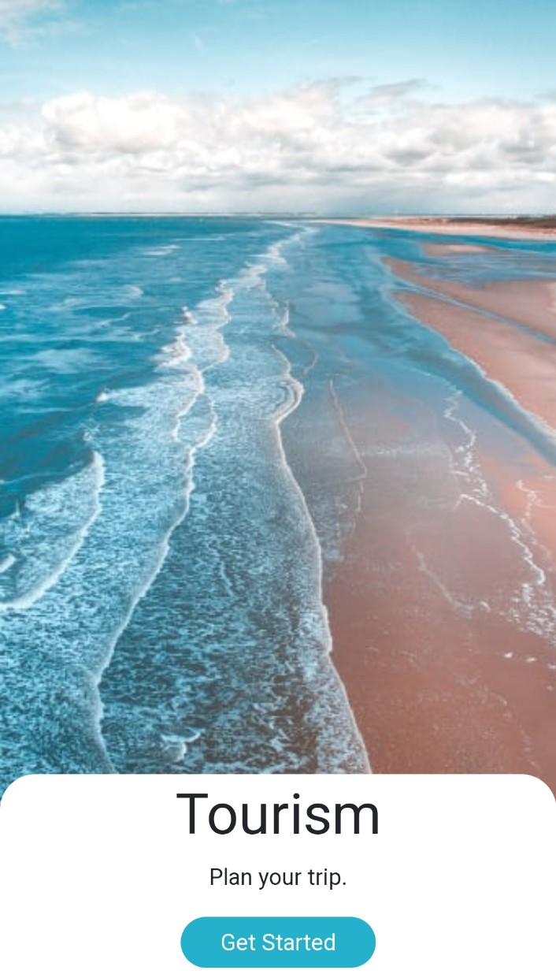

CLICK ON GET STARTED TO VISIT TO FAVOUTITE PLACES.

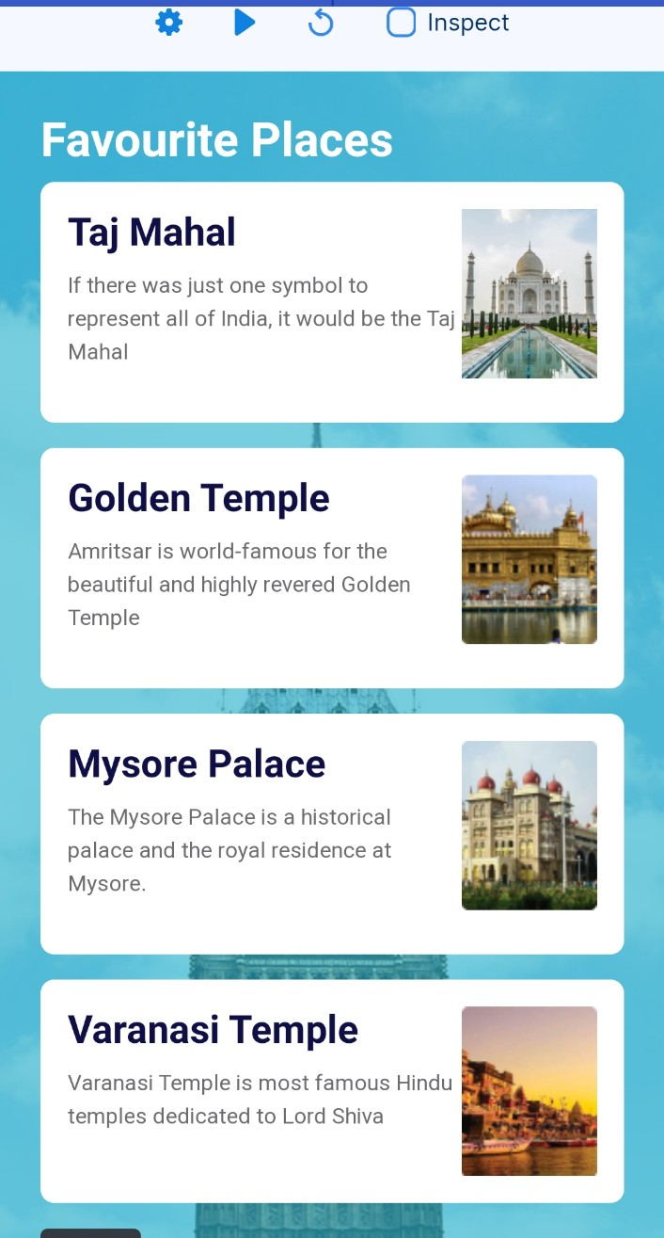

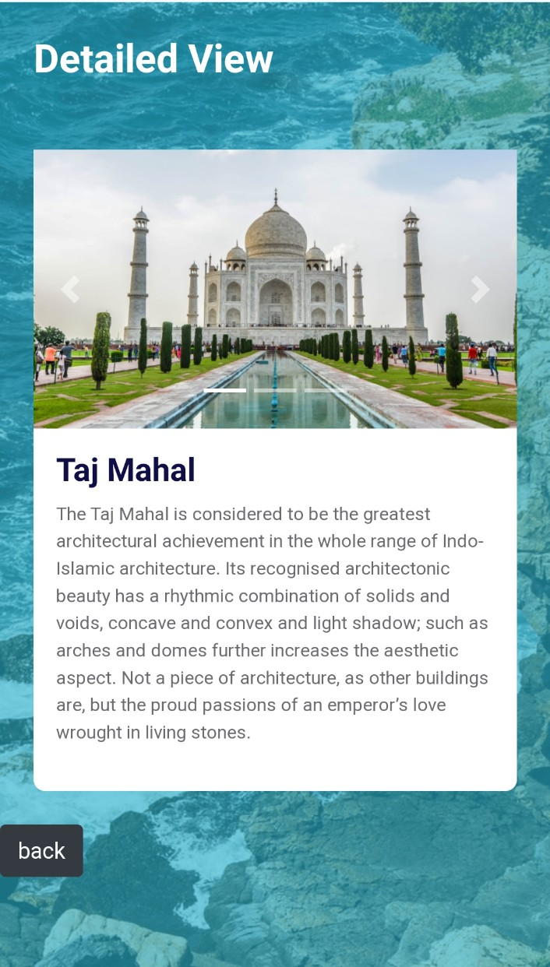

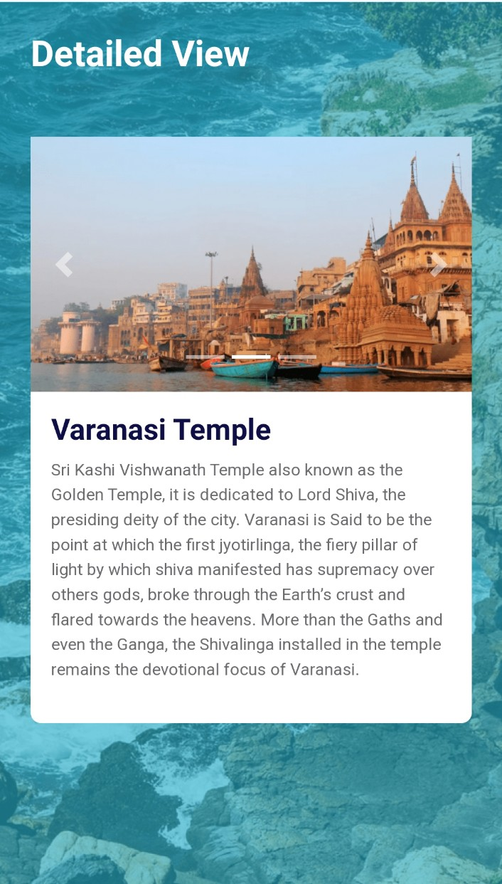

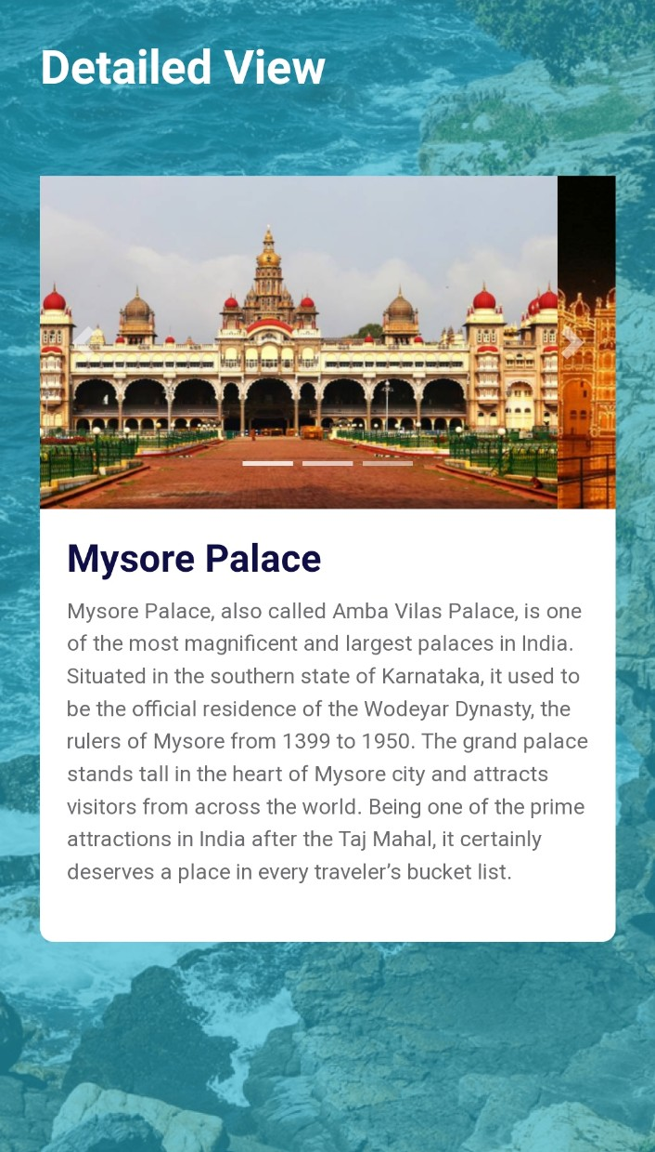

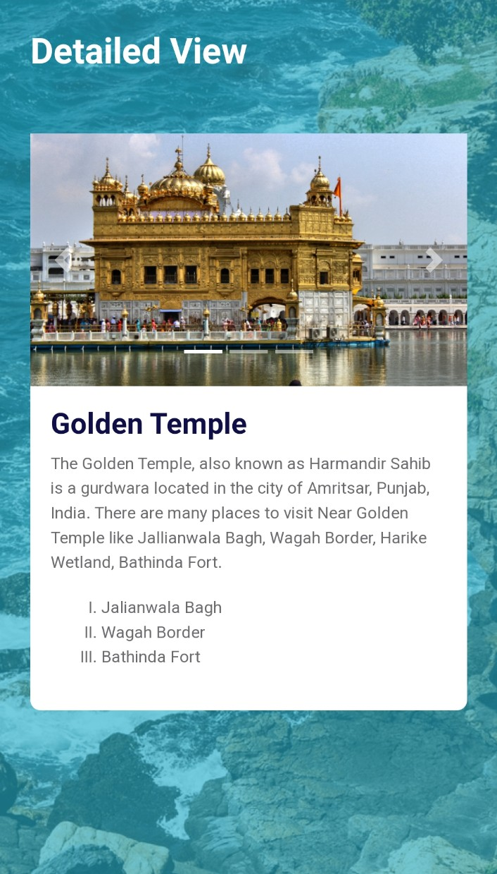

TRAVEL WEBSITE

THANK YOU